Job no:01

**Job name: Use** Of html **heading paragraph Image Italic horizontal Tag bold**

**Input:**

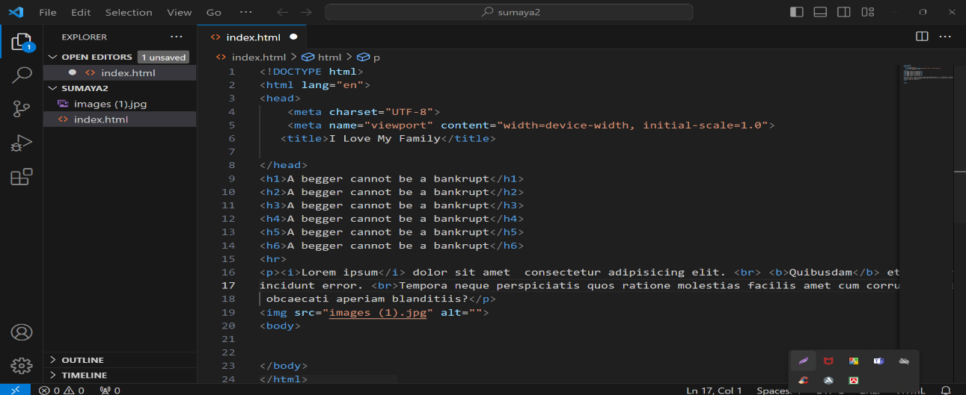

**Output:**

